Data view in Power BI
Data view helps you inspect, explore, and understand data in your Power BI Desktop model. It's different from how you view tables, columns, and data in Power Query Editor. With Data view, you're looking at your data after it has been loaded into the model.
When you're modeling your data, sometimes you want to see what's actually in a table or column without creating a visual on the report canvas. You might want to see right down to the row level. This ability is especially useful when you're creating measures and calculated columns, or you need to identify a data type or data category.
Let's take a closer look at some of the elements found in Data view.
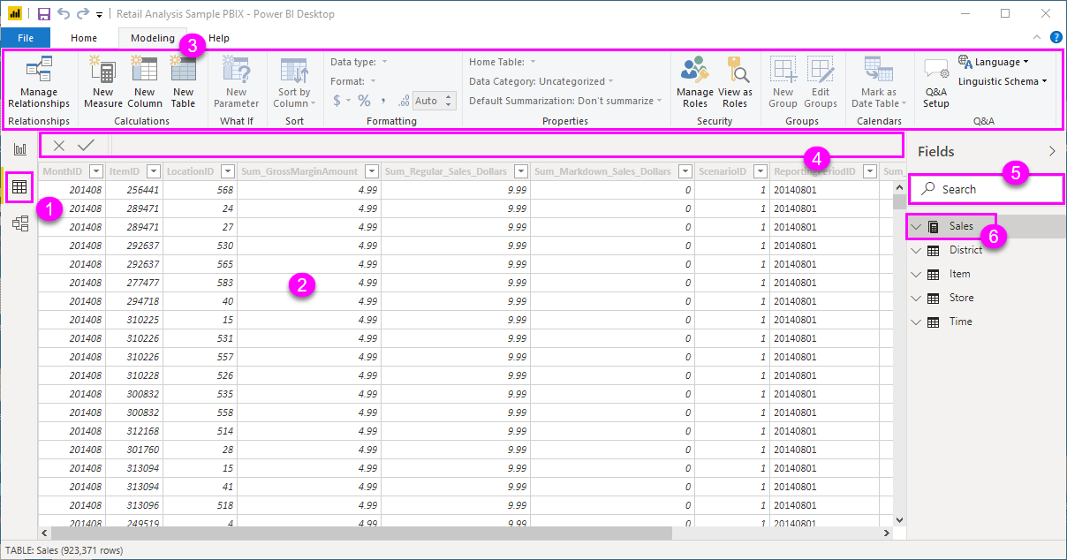
- Data view icon. Select this icon to enter Data view.
- Data Grid. This area shows the selected table and all columns and rows in it. Columns hidden from Report view are greyed out. You can right-click on a column for options.
- Modeling ribbon. Here you can manage relationships, create calculations, change data type, format, data category for a column.
- Formula bar. Enter Data Analysis Expression (DAX) formulas for Measures and Calculated columns.
- Search. Search for a table or column in your model.
- Fields list. Select a table or column to view in the data grid.

Data view in Power BI
Power BI Desktop includes a Report view, where you can create any number of report pages with visualizations. Report view in Power BI Desktop provides a similar design experience to the report's editing view in the Power BI service. You can move visualizations around, copy and paste, merge, and so on.
The difference between them is when using Power BI Desktop, you can work with your queries and model your data to make sure your data supports the best insights in your reports. You can then save your Power BI Desktop file wherever you like, whether it's your local drive or to the cloud.

Let's take a look!
When you first load data in Power BI Desktop, you'll see the Report view with a blank canvas.
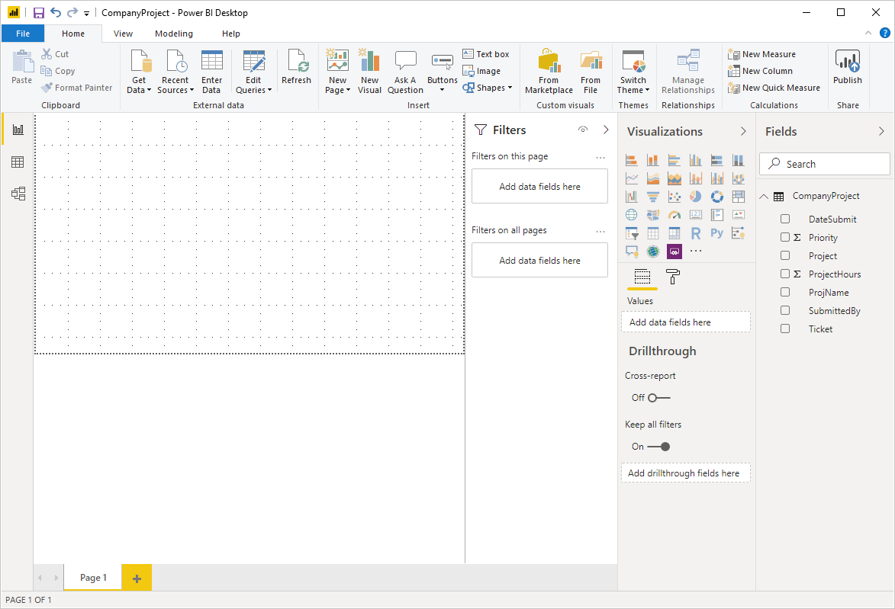
You can switch between Report, Data, and Relationship views by selecting the icons in the left-hand navigation pane:
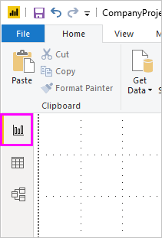
Once you've added some data, you can add fields to a new visualization in the canvas.
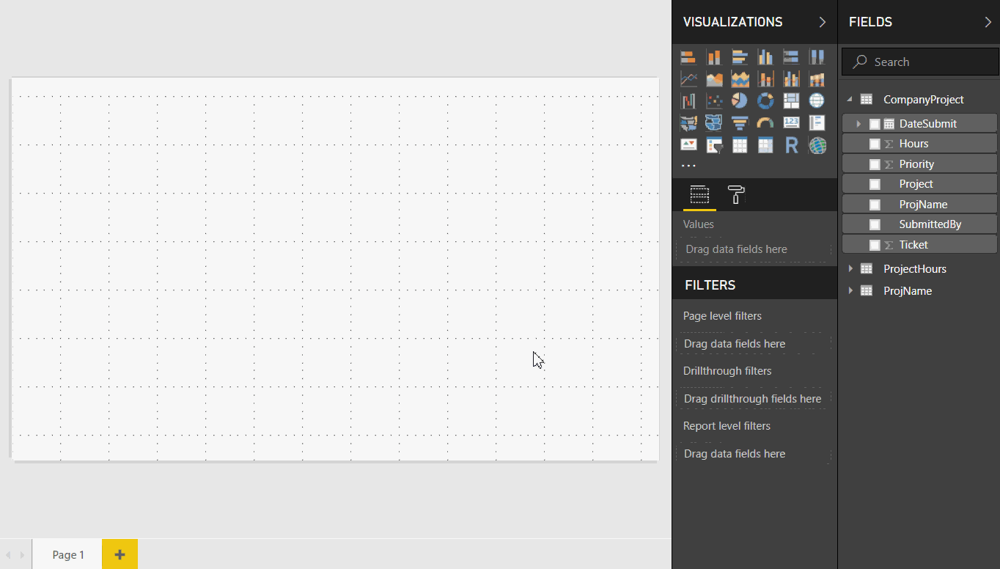
To change the type of visualization, you can select it on the canvas, then select a new type in Visualizations.
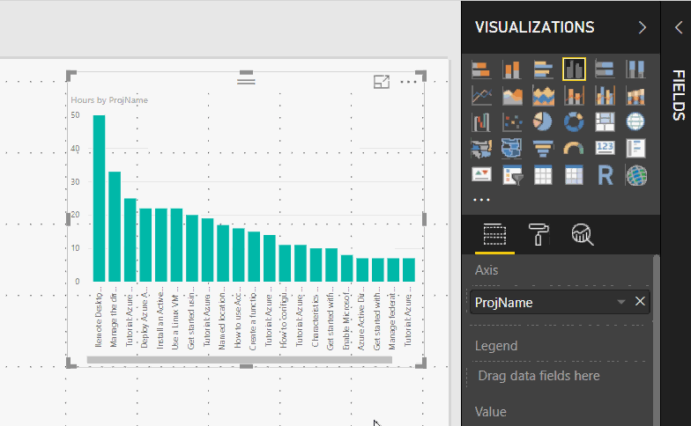
Tip
Be sure to experiment with different visualization types. It's important your visualization convey information in your data clearly.
A report will have at least one blank page to start. Pages appear in the navigator pane just to the left of the canvas. You can add all sorts of visualizations to a page, but it's important not to overdo it. Too many visualizations on a page make it look busy and difficult to find the right information. You can add new pages to your report. Just click New Page on the ribbon.
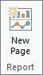
To delete a page, click the X on the page's tab at the bottom of the Report view.
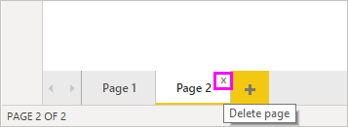
Note
Reports and visualizations can't be pinned to a dashboard from Power BI Desktop. To do that, you'll need to publish to your Power BI site. For more information, see Publish datasets and reports from Power BI Desktop.

Copy and paste between reports
You can easily take a visual from one Power BI Desktop report and paste it into another report. Simply use the Ctrl+C keyboard shortcut to copy your report visual. In the other Power BI Desktop report, use Ctrl+V to paste the visual into the other report. You can select one visual at a time, or all visuals on a page to copy, then paste into the destination Power BI Desktop report.
The ability to copy and paste visuals is useful for people who build and updates multiple reports frequently. When copying between files, settings and formatting that have been explicitly set in the formatting pane will carry forward, while visual elements relying on a theme or the default settings automatically update to match the theme of the destination report. So when you get a visual formatted and looking just the way you want, you can copy and paste that visual into new reports and preserve all that good formatting work.
If the fields in your model are different, you'll see an error on the visual and a warning about which fields don't exist. The error is similar to the experience you see when you delete a field in the model that a visual is using.
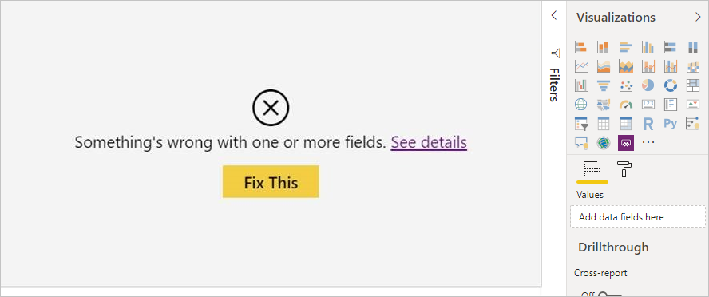
To correct the error, just replace the broken fields with the fields you want to use from the model in the report to which you pasted the visual. If you're using a custom visual, you must also import that custom visual to the destination report.

Hide report pages
When you create a report, you can also hide pages from a report. This approach might be useful if you need to create underlying data or visuals in a report, but you don't want those pages to be visible to others, such as when you create tables or supporting visuals that are used in other report pages. There are many other creative reasons you might want to create a report page, then hide it from a report you want to publish.
Hiding a report page is easy. Simply right-click on the report page tab, and select Hide from the menu that appears.
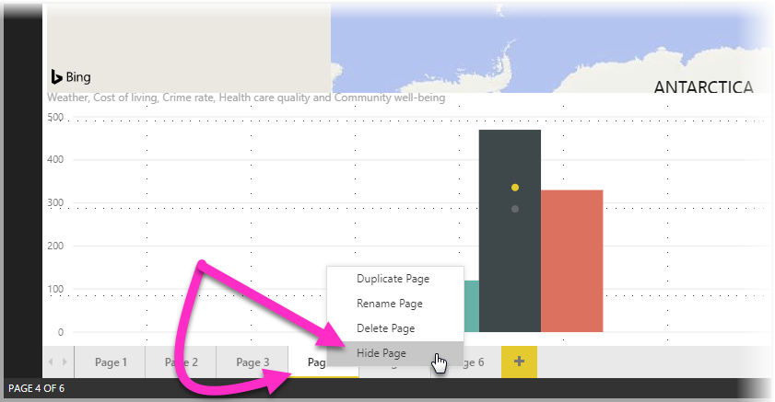
There are a few considerations to keep in mind when hiding a report page:
- You can still see a hidden report view when in Power BI Desktop, even though the page's title is grayed out. In the following image, Page 4 is hidden.
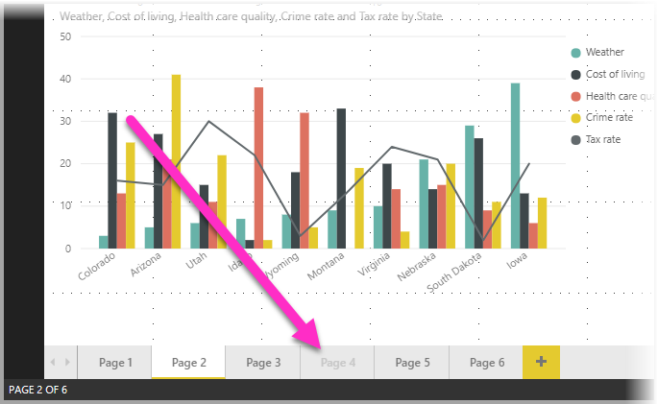
- You cannot see a hidden report page when viewing the report in the Power BI service.
- Hiding a report page is not a security measure. The page can still be accessed by users, and its content is still accessible using drill-through, and other methods.
- When a page is hidden, when in View mode, no view-mode navigation arrows are shown.

Data Model view in Power BI
Model view shows all of the tables, columns, and relationships in your model. This view can be especially helpful when your model has complex relationships between many tables.
Select the Model icon near the side of the window to see a view of the existing model. Hover your cursor over a relationship line to show the columns that are used.
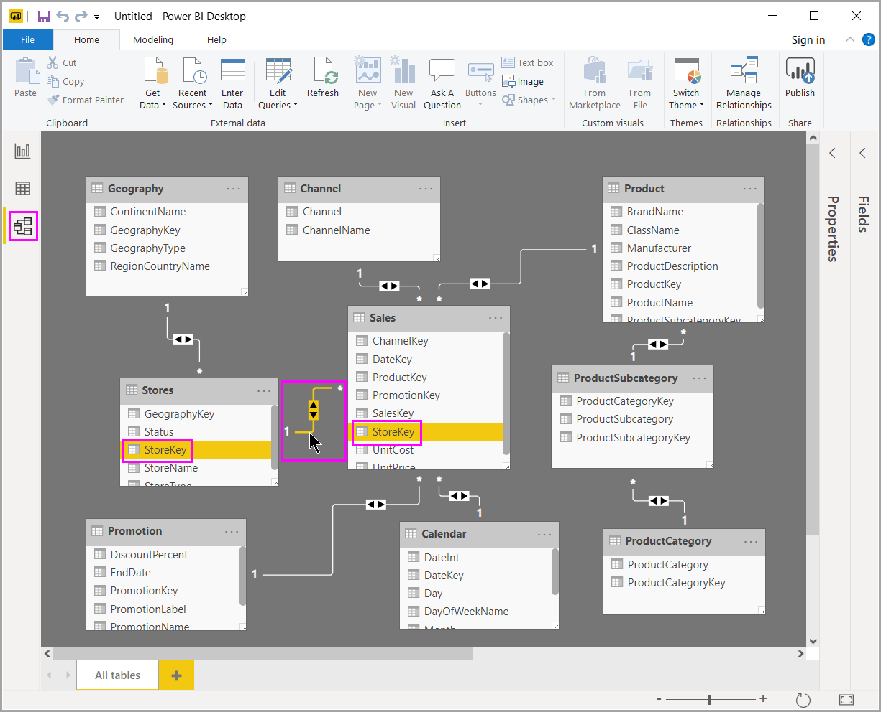
In the figure, the Stores table has a StoreKey column that’s related to the Sales table, which also has a StoreKey column. The two tables have a Many to One (*:1) relationship. An arrow in the middle of the line shows the direction of the filter context flow. The double arrows mean the cross-filter direction is set to Both.
You can double-click a relationship to open it in the Edit Relationship dialog box.

Power Query Editor
Access these views by selecting one of the three icons along the left side of Power BI Desktop. In the following image, Report view is selected, indicated by the yellow band beside the icon.
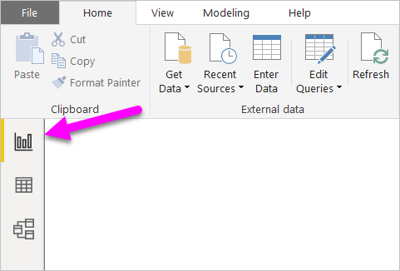
Power BI Desktop also comes with Power Query Editor. Use Power Query Editor to connect to one or many data sources, shape and transform the data to meet your needs, then load that model into Power BI Desktop.
This document provides an overview of the work with data in the Power Query Editor, but there's more to learn. At the end of this document, you’ll find links to detailed guidance about supported data types. You'll also find guidance about connecting to data, shaping data, creating relationships, and how to get started.
But first, let’s see get acquainted with Power Query Editor.

Power Query Editor
To get to Power Query Editor, select Edit Queries from the Home tab of Power BI Desktop.
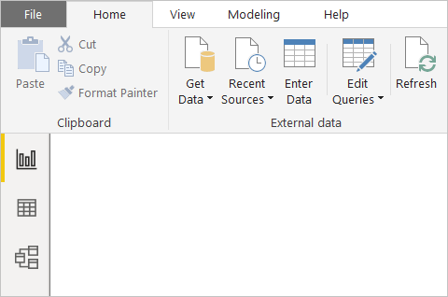
With no data connections, Power Query Editor appears as a blank pane, ready for data.
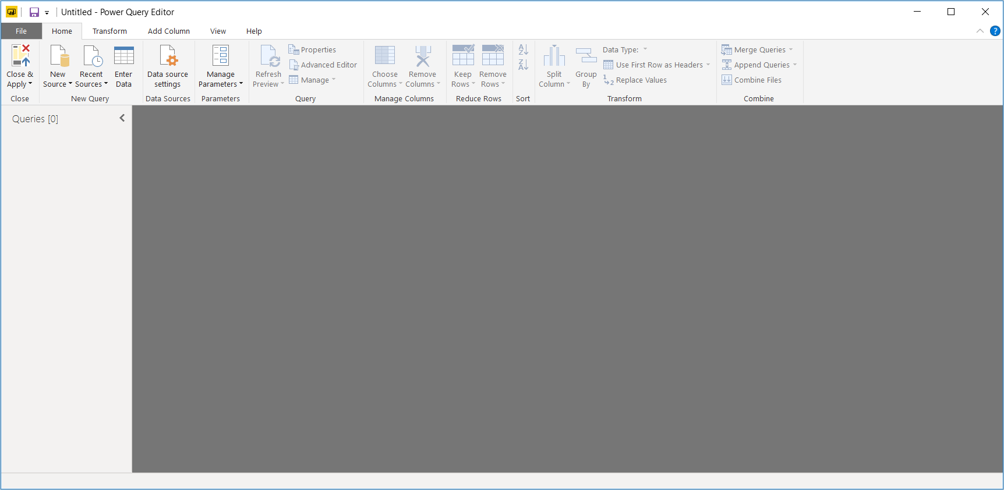
Once a query is loaded, Power Query Editor view becomes more interesting. If we connect to the following Web data source, Power Query Editor loads information about the data, which you can then begin to shape:
Here’s how Power Query Editor appears once a data connection is established:
- In the ribbon, many buttons are now active to interact with the data in the query.
- In the left pane, queries are listed and available for selection, viewing, and shaping.
- In the center pane, data from the selected query is displayed and available for shaping.
- The Query Settings pane appears, listing the query’s properties and applied steps.
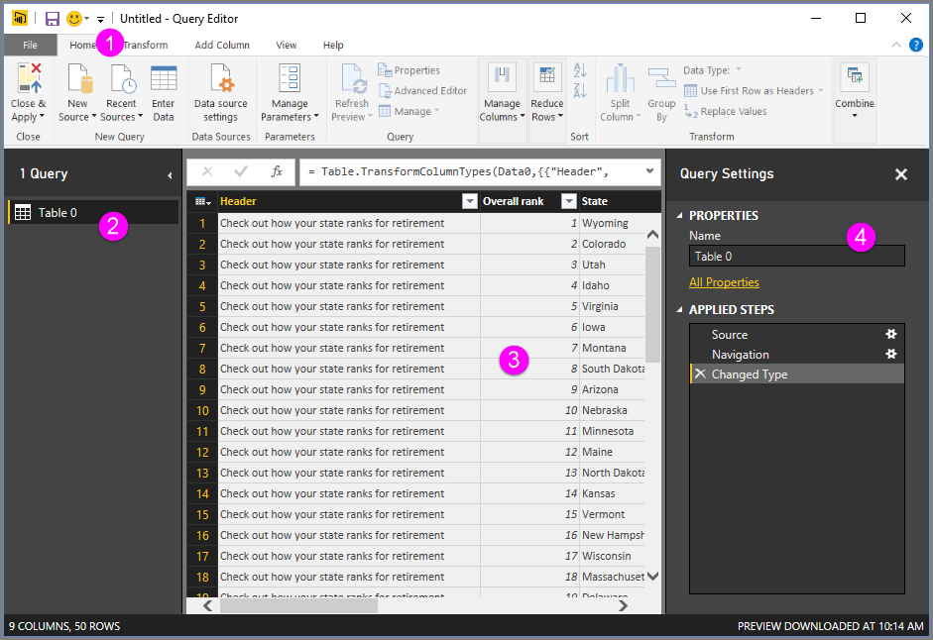
We’ll look at each of these four areas: the ribbon, the Queries pane, the Data view, and the Query Settings pane.

The query ribbon
The ribbon in Power Query Editor consists of four tabs: Home, Transform, Add Column, and View.
The Home tab contains the common query tasks.
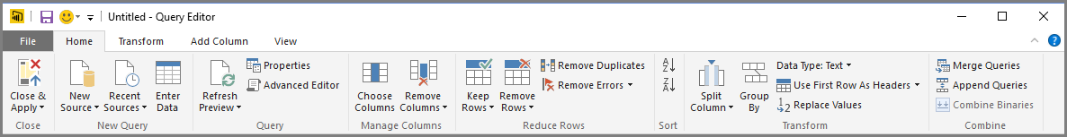
To connect to data and begin the query building process, select New Source. A menu appears, providing the most common data sources.
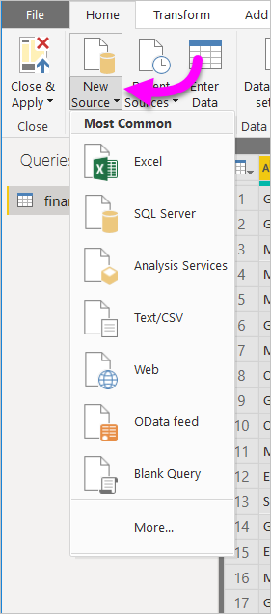
For more information about available data sources, see Data Sources. For information about connecting to data, including examples and steps, see Connect to Data.
The Transform tab provides access to common data transformation tasks, such as:
- Adding or removing columns
- Changing data types
- Splitting columns
- Other data-driven tasks
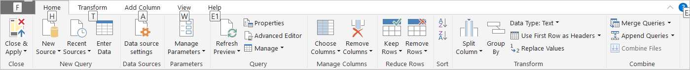
For more information about transforming data, including examples, see Tutorial: Shape and combine data in Power BI Desktop.
The Add Column tab provides additional tasks associated with adding a column, formatting column data, and adding custom columns. The following image shows the Add Column tab.
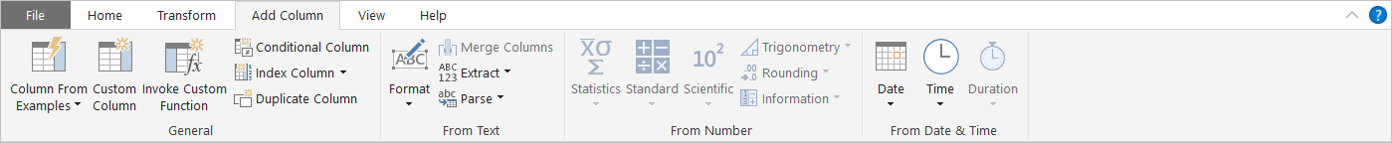
The View tab on the ribbon is used to toggle whether certain panes or windows are displayed. It’s also used to display the Advanced Editor. The following image shows the View tab.
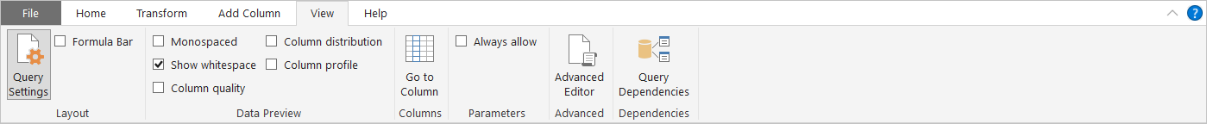
It’s useful to know that many of the tasks available from the ribbon are also available by right-clicking a column, or other data, in the center pane.

The left (Queries) pane
The left pane, or Queries pane, displays the number of active queries and the name of the query. When you select a query from the left pane, its data is displayed in the center pane, where you can shape and transform the data to meet your needs. The following image shows the left pane with a query.
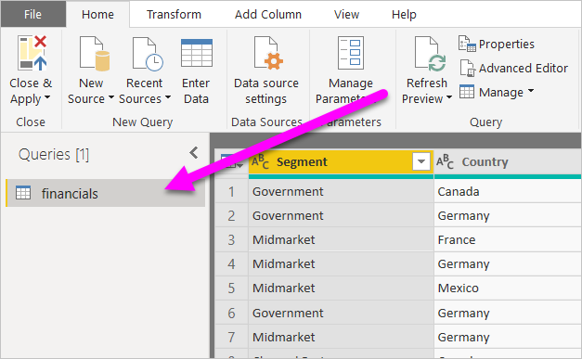

The center (Data) pane
In the center pane, or Data pane, data from the selected query is displayed. This pane is where much of the work of the Query view is accomplished.
In the following image shows the Web data connection established earlier. The Product column is selected, and its header is right-clicked to show the available menu items. Notice that many of these right-click menu items are the same as buttons in the ribbon tabs.
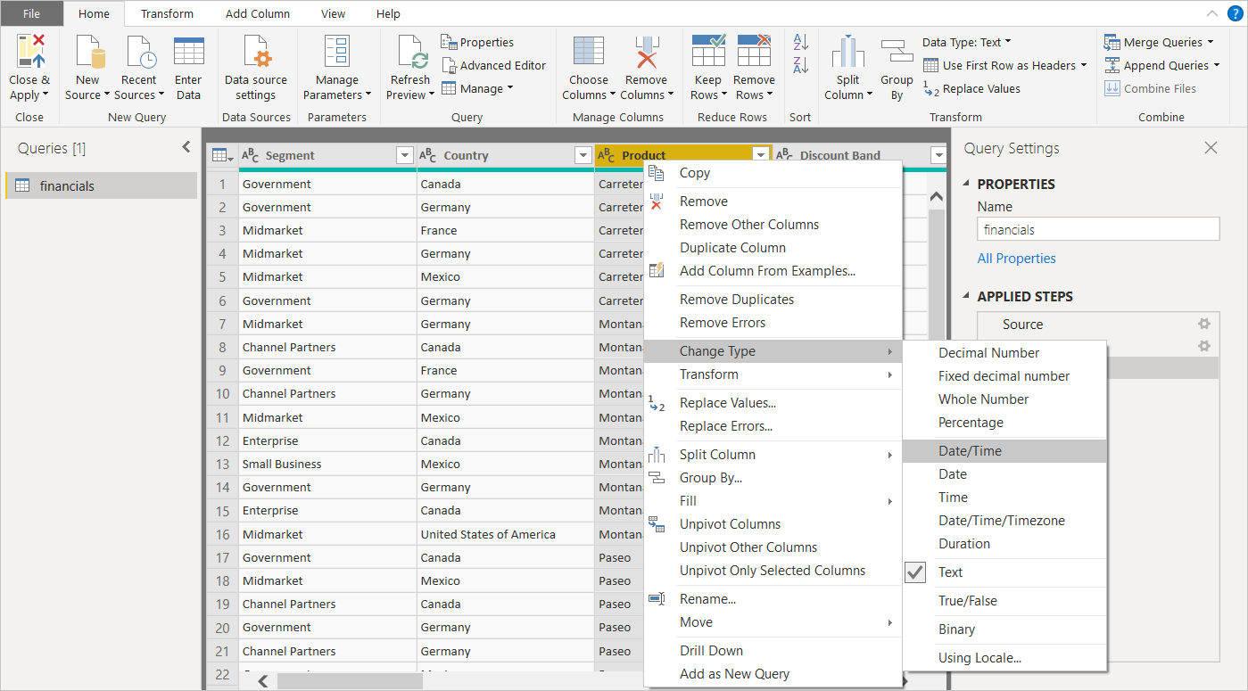
When you select a right-click menu item (or a ribbon button), the query applies the step to the data. It also saves step as part of the query itself. The steps are recorded in the Query Settings pane in sequential order, as described in the next section.

The right (Query Settings) pane
The right pane, or Query Settings pane, is where all steps associated with a query are displayed. For example, in the following image, the Applied Steps section of the Query Settings pane reflects the fact that we just changed the type of the Overall score column.
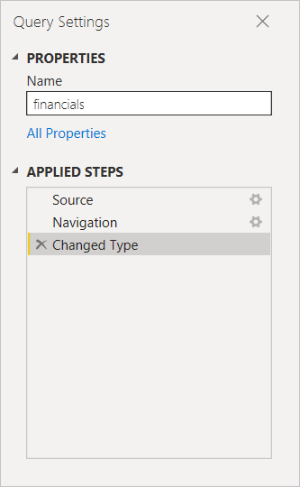
As additional shaping steps are applied to the query, they're captured in the Applied Steps section.
It’s important to know that the underlying data isn't changed. Rather, Power Query Editor adjusts and shapes its view of the data. It also shapes and adjusts the view of any interaction with the underlying data that occurs based on Power Query Editor’s shaped and modified view of that data.
In the Query Settings pane, you can rename steps, delete steps, or reorder the steps as you see fit. To do so, right-click the step in the Applied Steps section, and choose from the menu that appears. All query steps are carried out in the order they appear in the Applied Steps pane.
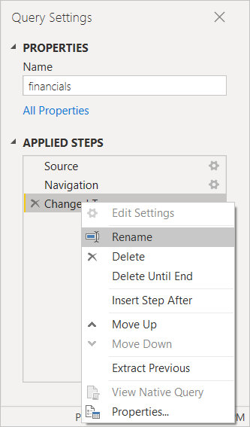

Advanced Editor
The Advanced Editor lets you see the code that Power Query Editor is creating with each step. It also lets you create your own shaping code. To launch the advanced editor, select View from the ribbon, then select Advanced Editor. A window appears, showing the existing query code.
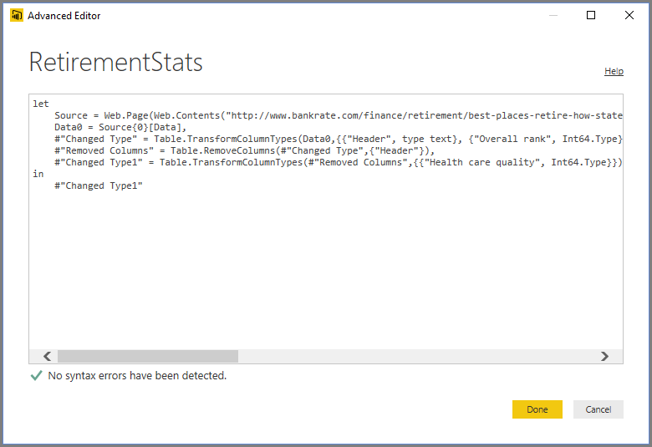
You can directly edit the code in the Advanced Editor window. To close the window, select the Done or Cancel button.

